**David Okeke**

**CTEC 298**

**Matplot Assignment**

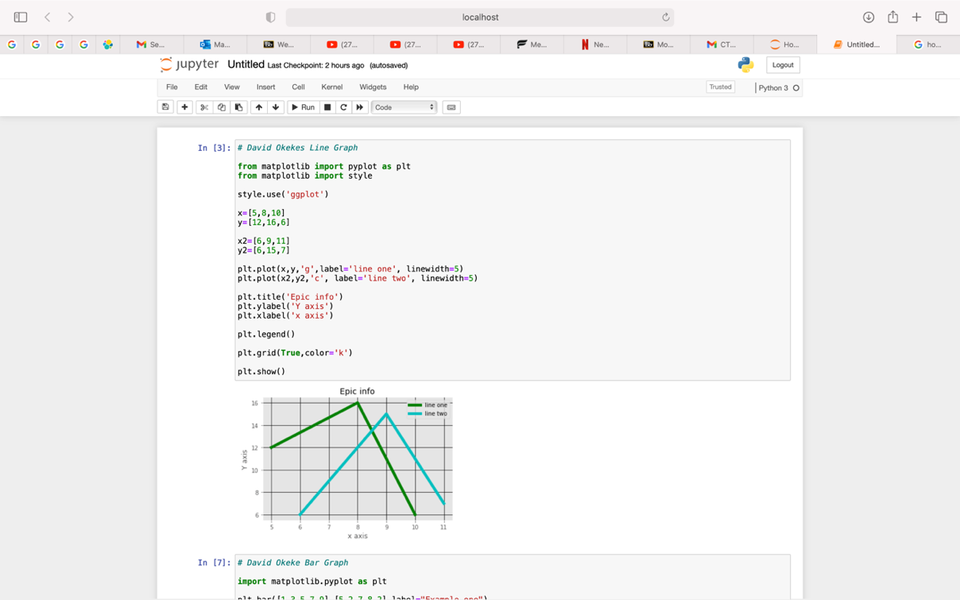

**This screenshot displays a line graph, as you can see line one and two with its plotted points.**

**This screenshot displays a bar graph, with x and y axis bar number and bar height.**

**This screenshot displays a histogram of population ages and bins.**

**This screenshot displays a scatter plot.**

**This screenshot displays a stack plot using labels sleeping, eating, working, and playing.**

**This screenshot displays a pie plot with labeled activities like sleeping, eating, working, and playing.**

**This screenshot displays a multiple plots.**